JOBSHEET 10

MS Excel

Team teaching

Politeknik Negeri Malang

JOBSHEET 10

MS Excel 2010 - 2016

1. Job Instructions
2. Working on case studies, trainings and assignments on the worksheet properly and correctly.
3. Not allowed to cheat tasks with other students. If the cheating occurred, the lecturer will impose a penalty to students who asked and gave the answer then both student scores will be down to 0.
4. All answers of case studies, exercises and assignments are done in the available columns, and all of you are obliged to write down the work steps.
5. Work is collected with the format NAME-STUDENT ID-T10-CLASS in the folder.
6. After the student finished the case studies, training and assignments, the work has to be  
   submitted to the lecturer to do the assessment.
7. Students can ask questions if the work descriptions are poorly understood.
8. Worksheet
9. Do the following questions:
   * Open Ms **Excel** .
   * Click **Blank Workbook** to open a new spreadsheet.
   * Change the **Ribbon Display Options** to **Show Tabs**.
   * Using the **Customize Quick Access Toolbar**, click to add **New**, **Quick Print**, and **Spelling**.
   * In the **Tell me bar**, type the word **Color**. Hover over **Fill Color** and choose a **yellow**. This will fill a cell with the color yellow.
   * Change the worksheet view to the **Page Layout** option.
   * When you're finished, your screen should look like this:

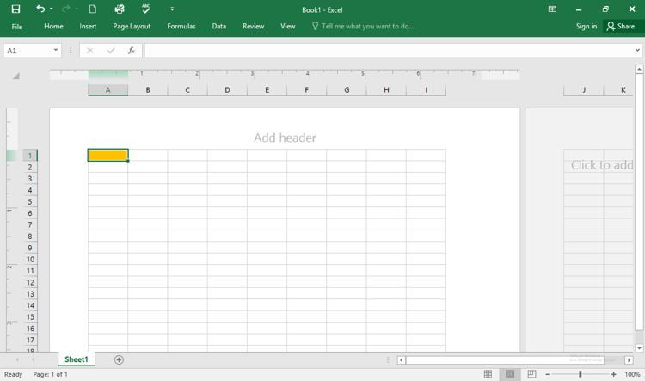

* + Save by name T10.1_started_NAME.pptx

1. Do the following questions:
   * Open excel2016_cellbasics_practice.xlsx
   * Select cell **D6** and type **hlee**.
   * **Clear the contents** in row 14.
   * **Delete** column G.
   * Using either **cut and paste** or **drag and drop**, move the contents of row 18 to row 14.
   * Use the **fill handle** to put an X in cells F9:F17.
   * When you're finished, your workbook should look like this:

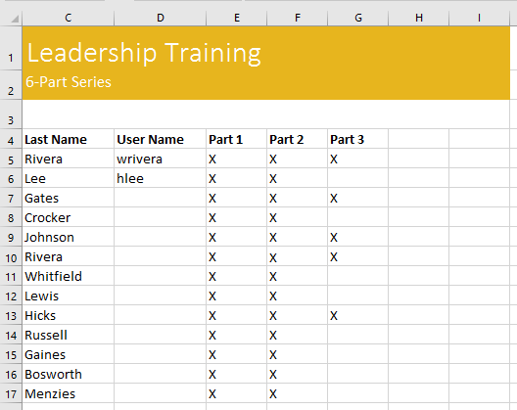

* + Save by name T10.2_cellbasics_NAME.pptx

1. Do the following questions:
   * Open excel2016_modifyingcells_practice.xlsx
   * **Autofit Column Width** for the entire workbook.
   * Modify the **row height** for rows 3 to 14 to **22.5 (30 pixels)**.
   * **Delete** row 10.
   * **Insert** a column to the left of column C. Type **SECONDARY CONTACT** in cell **C2**.
   * Make sure cell **C2** is still selected and choose **Wrap Text**.
   * **Merge and Center** cells A1:F1.
   * **Hide** the **Billing Address** and **Phone** columns.
   * When you're finished, your workbook should look something like this:

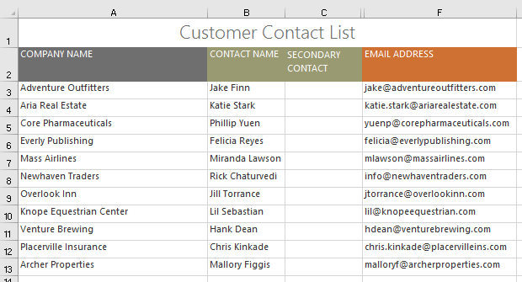

* + Save by name T10.3_modifyingcells_NAME.pptx

1. Do the following questions:
   * Open excel2016_formattingcells_practice.xlsx
   * Click the **Challenge** worksheet tab in the bottom-left of the workbook.
   * Change the **cell style** in cells **A2:H2** to **Accent 3**.
   * Change the **font size** of row 1 to **36** and the font size for the rest of the rows to **18**.
   * **Bold** and **underline** the text in row 2.
   * **Change the font** of row 1 to a font of your choice.
   * **Change the font** of the rest of the rows to a different font of your choice.
   * Change the **font color** of row 1 to a color of your choice.
   * Select all of the text in the worksheet, and change the **horizontal alignment** to center align and the **vertical alignment** to middle align.
   * When you're finished, your worksheet should look something like this:

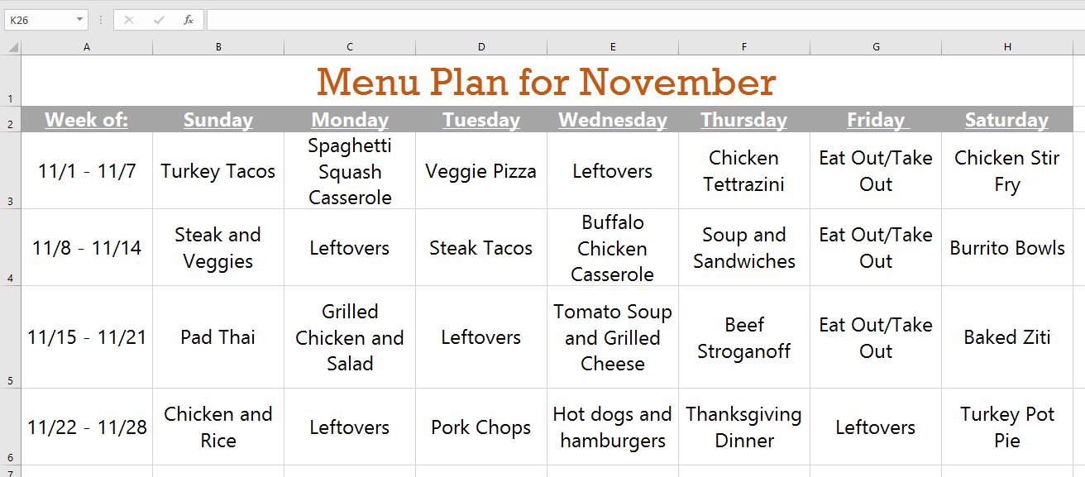

* + Save by name T10.4_formattingcells_NAME.pptx

1. Do the following questions:
   * Open excel2016_numberformats_practice.xlsx
   * In cell **D2**, type today's date and press **Enter**.
   * Click cell **D2** and verify that it is using a **Date** number format. Try changing it to a different date format (for example, **Long Date**).
   * In cell **D2**, use the **Format Cells** dialog box to choose the **14-Mar-12** date format.
   * Change the sales tax rate in cell **D8** to the **Percentage** format.
   * Apply the **Currency** format to all of **column B**.
   * In cell **D8**, use the **Increase Decimal** or **Decrease Decimal** command to change the number of decimal places to **one**. It should now display **7.5%**.
   * When you're finished, your spreadsheet should look like this:

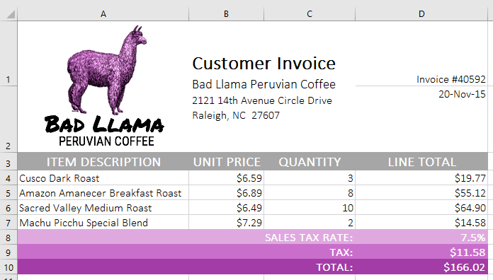

* Save by name T10.5_numberformats_NAME.pptx

**-HAVE A GREAT TIME DOING IT-**